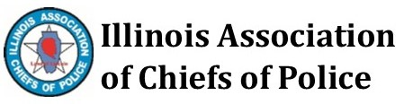
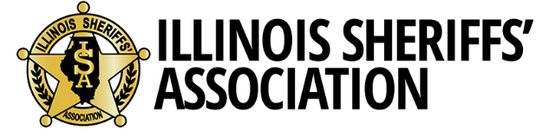

February 13, 2020
Sent to:
Governor Pritzker
Legislative Leaders

We are writing to make you aware of a statewide, immediate crisis in funding for training of law enforcement officers and to seek your support for an immediate supplemental appropriation.
The background is this: The sole source of training funding for the Illinois Law Enforcement Training and Standards Board (ILETSB) is revenue from the Illinois Traffic & Criminal Conviction Surcharge Fund (TACCSF). In other words, the revenue on every traffic ticket provides some funding for police training. In 2018 the General Assembly passed, the Fee Reform Act, HB 4594, which became effective July 1, 2019. This bill provided a new fee structure assessment process, and gave judges the authority to waive fee assessments on traffic convictions. As a result of this revised fine structure, ILETSB’s sole source of revenue is down 16% this fiscal year, and the gap appears to be widening, as the last two monthly contributions were down 36% and 56%, respectively, from the prior year’s figures.
As a result of this decrease in revenue, officers are unable to get all of the training that is mandated by the state and that we want them to have so that they can be better trained guardians of our communities. Classes are already being cancelled this year. That is why we call it a crisis.
A little more background: In a process that has worked well since the 1990s, ILETSB receives the surcharge money and distributes it to 15 regional Mobile Training Units that cover every part of the state to provide much of this mandated training. That amounts to about $5.5 million per year. Mobile Training Units also receive modest membership dues from nearly every local police department and sheriff’s office, many of which solely rely on the Mobile Teams to provide training for all of their officers. In Fiscal Year 2018, the Mobile Teams provided 41,824 hours of instruction to 143,288 officers for a total of 769,188 man-hours of training. This has been efficient and effective.
With the decline in surcharge money since last July, however, the Mobile Teams are now cancelling classes and have been asked to consider plans to shut down due to the shortage of funding. It should not come to this, and we believe it deserves immediate attention.
Obviously, this situation makes no sense, given the fact that the State of Illinois and Illinois General Assembly want officers to receive even more training. In 2016, the new Police and Community Relations Improvement Act required law enforcement to receive training in seven different mandated topics: Use of Force, Law Updates, Civil Rights, Cultural Competency, Constitutional Law, Procedural Justice, and Human Rights. Additional mandates have also been codified in the last three years that include training on Sexual Assault Trauma-Informed Response, Mental Health Awareness, Reporting of Child Abuse, and Officer Wellness.
No additional funding has been provided to address any of those eleven mandates. We all want our officers to be highly trained in order to respond to the complexities of society, but we have to provide the financial resources it requires to do so.
In addition to the funding impact for Mobile Training Units, the police academies around the state that provide basic training for new officers are not being paid by ILETSB for this important service. Consequently, those academies are now requiring local municipalities and counties to pay academy costs up front for every recruit – nearly $6,000 per officer in the hopes that some of this tuition will be reimbursed. These are unexpected costs that will drain the budgets of cities, villages, and counties who are already responsible for equipment and salary of those officers. Prior to this crisis, the academies would bill the Training Board for basic training and then be reimbursed.
We believe the immediate solution is to pass a supplemental appropriation as soon as possible to keep the academies, the MTUs, and ILETSB functioning at a high level. We are told the exact amount of the supplemental is still being discussed, but the amount needed to cover what originally had been budgeted is approximately $5 million. When this issue comes to you, please be aware that law enforcement agencies that you represent will benefit directly from this additional funding.
In addition to addressing this crisis, the broader issue of how to fund law enforcement training in Illinois in the future also needs to be addressed this spring, because the method that has worked for more than twenty years is now failing our communities.
In the meantime, during a time of crisis, we ask for your immediate support for a supplemental appropriation to the Illinois Law Enforcement Training and Standards Board to provide direct support to the Mobile Training Units and the police academies.
Please demonstrate your support for law enforcement by supporting this additional funding. We thank you in advance for your consideration.
Sincerely,

Jim Kaitschuk Ed Wojcicki
Executive Director Executive Director
Illinois Sheriffs’ Association Illinois Association of Chiefs of Police
jim@ilsheriff.org ed@ilchiefs.org

